**Лабораторная работа №3.Работа с HTML и CSS. Простые приёмы работа с DOM и BOM.**

**Сухоруков Сергей 3-041**

**Цель работы:** практика работы с HTML и CSS, а также работа с **DOM и BOM.**



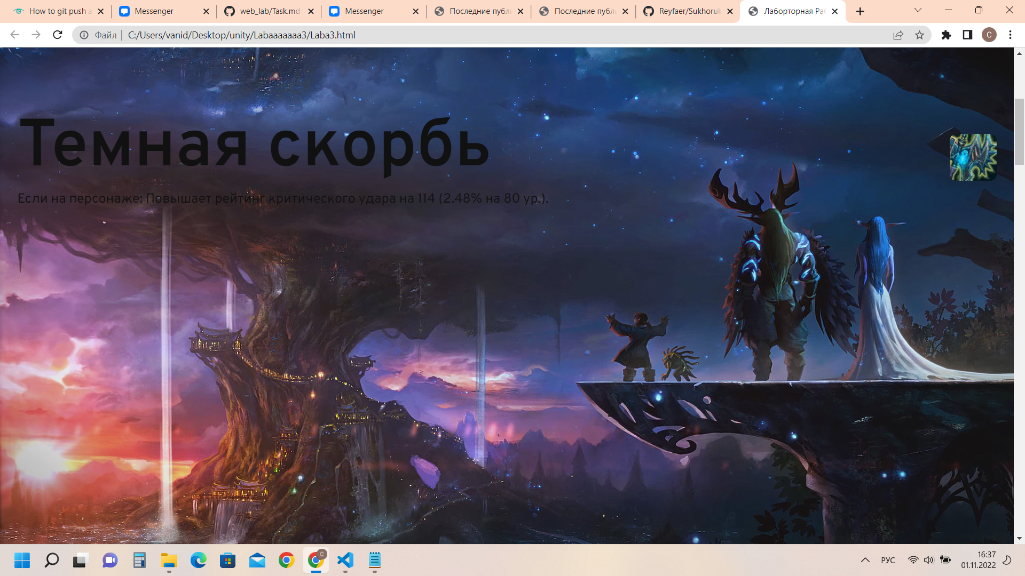

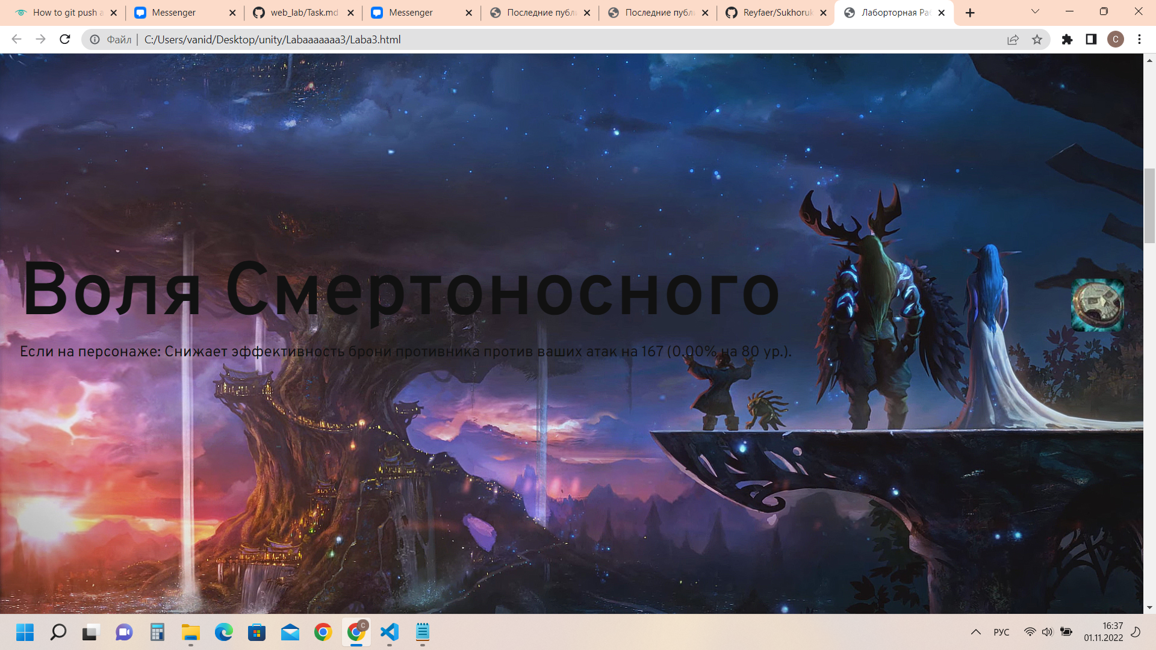

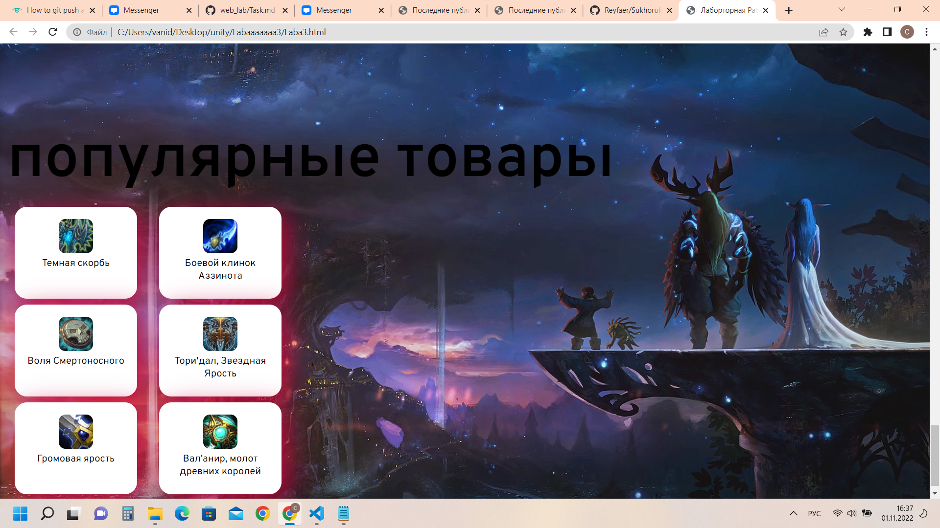

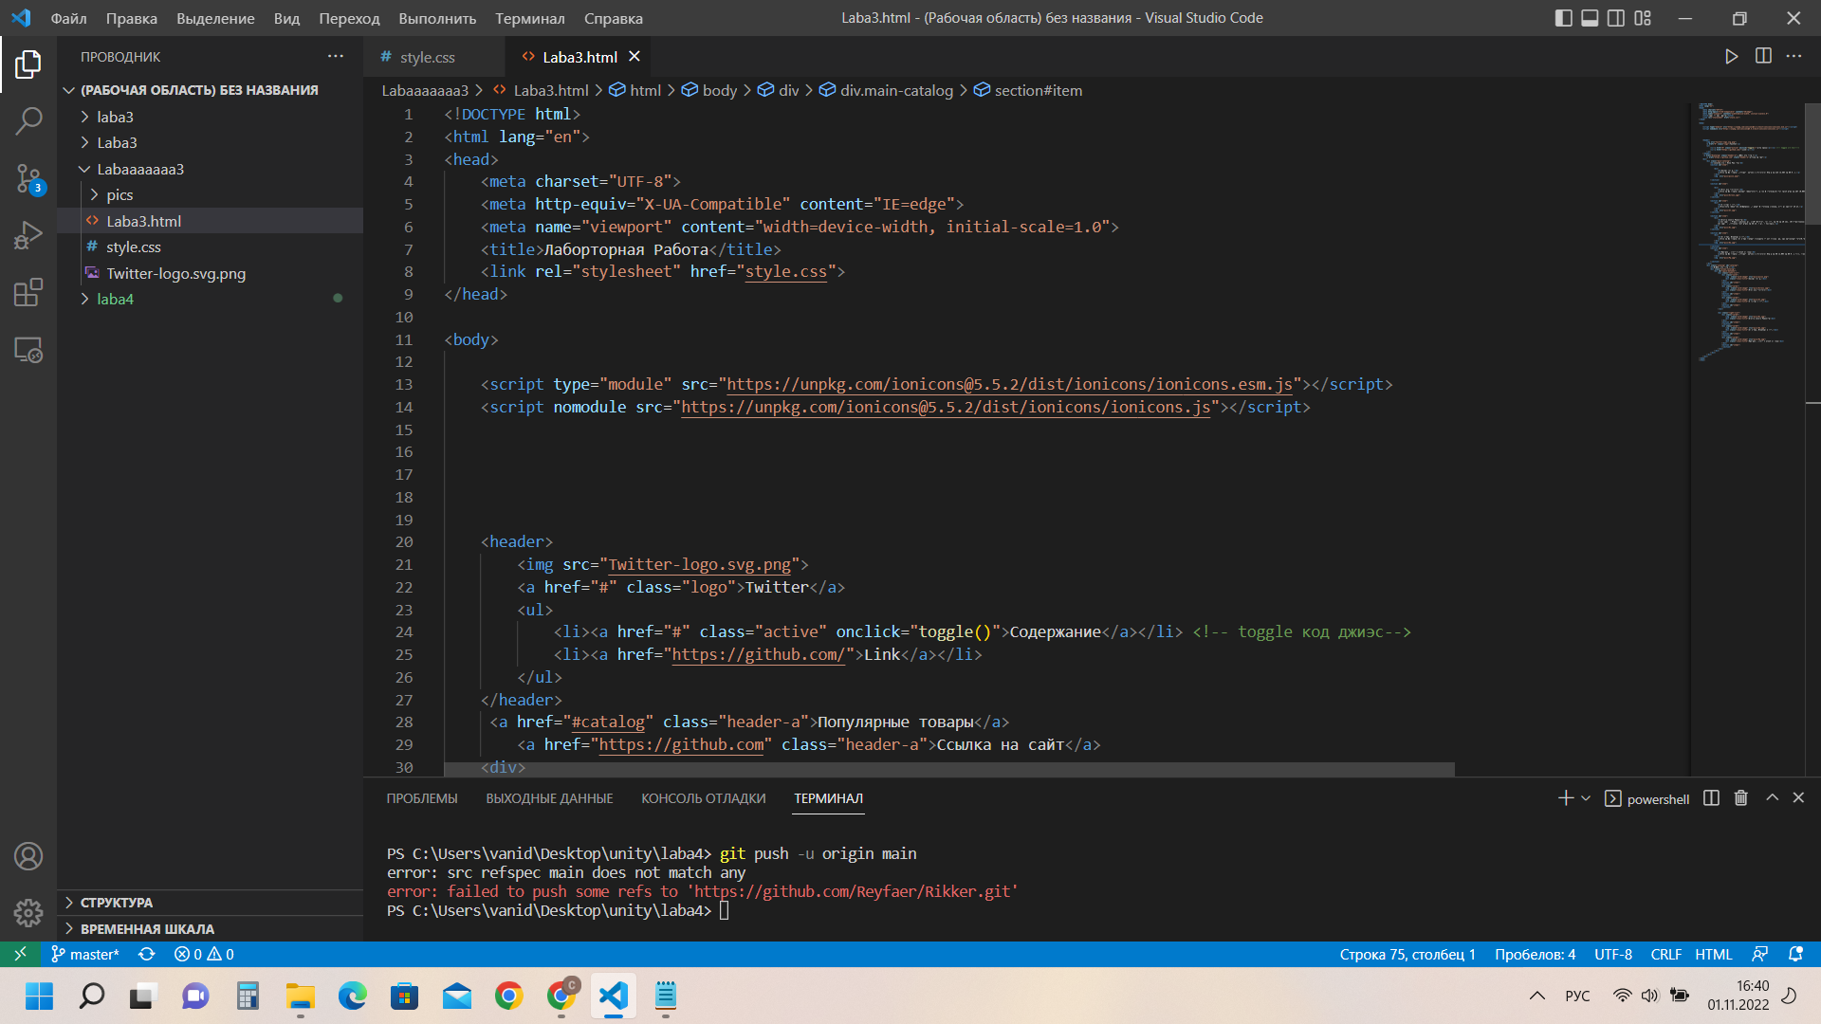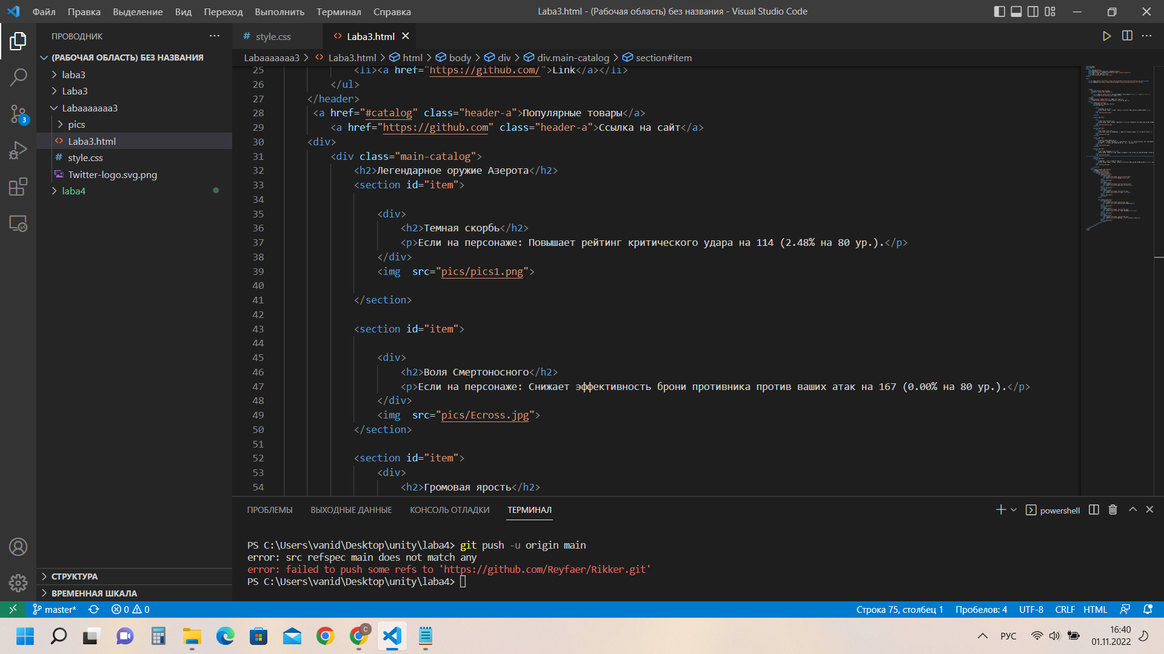

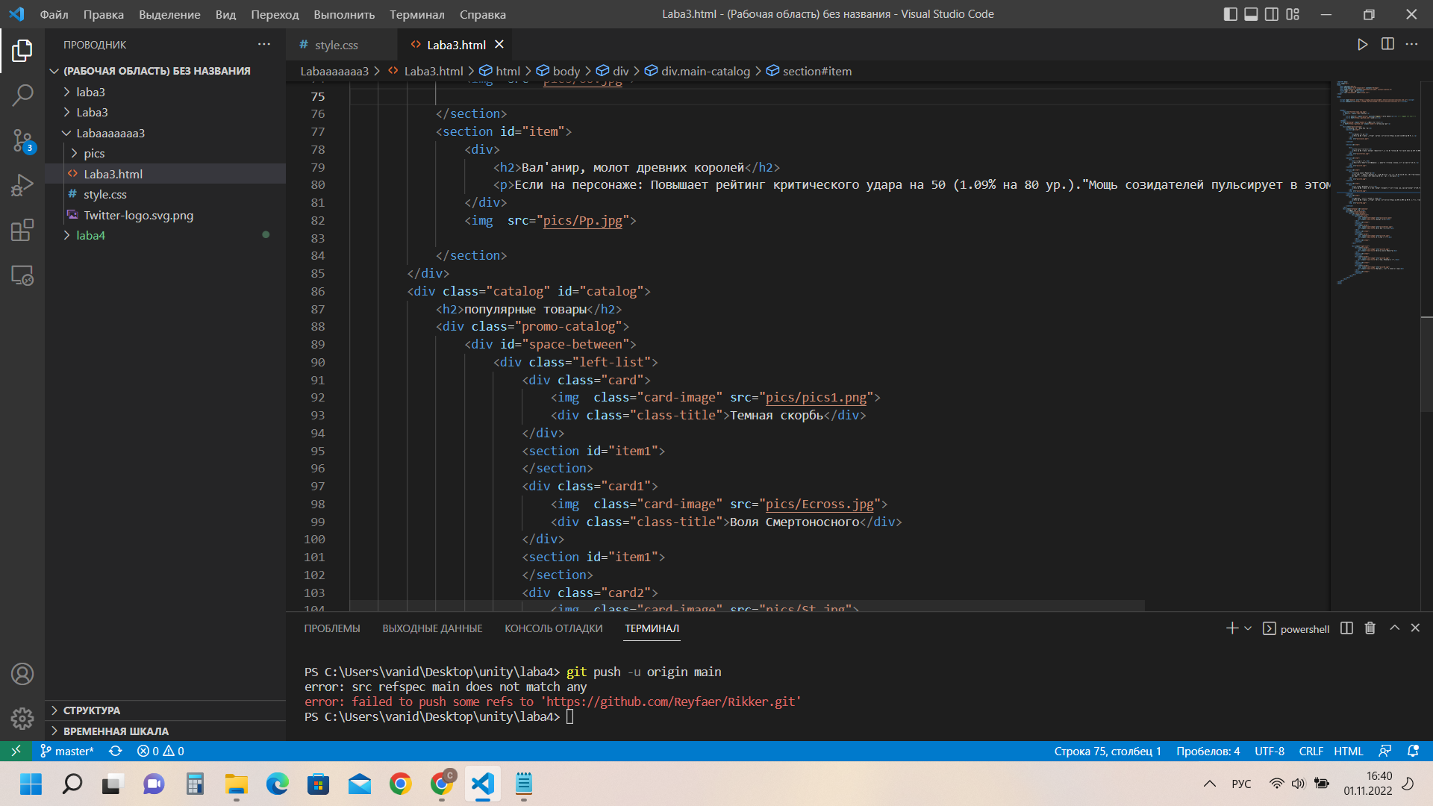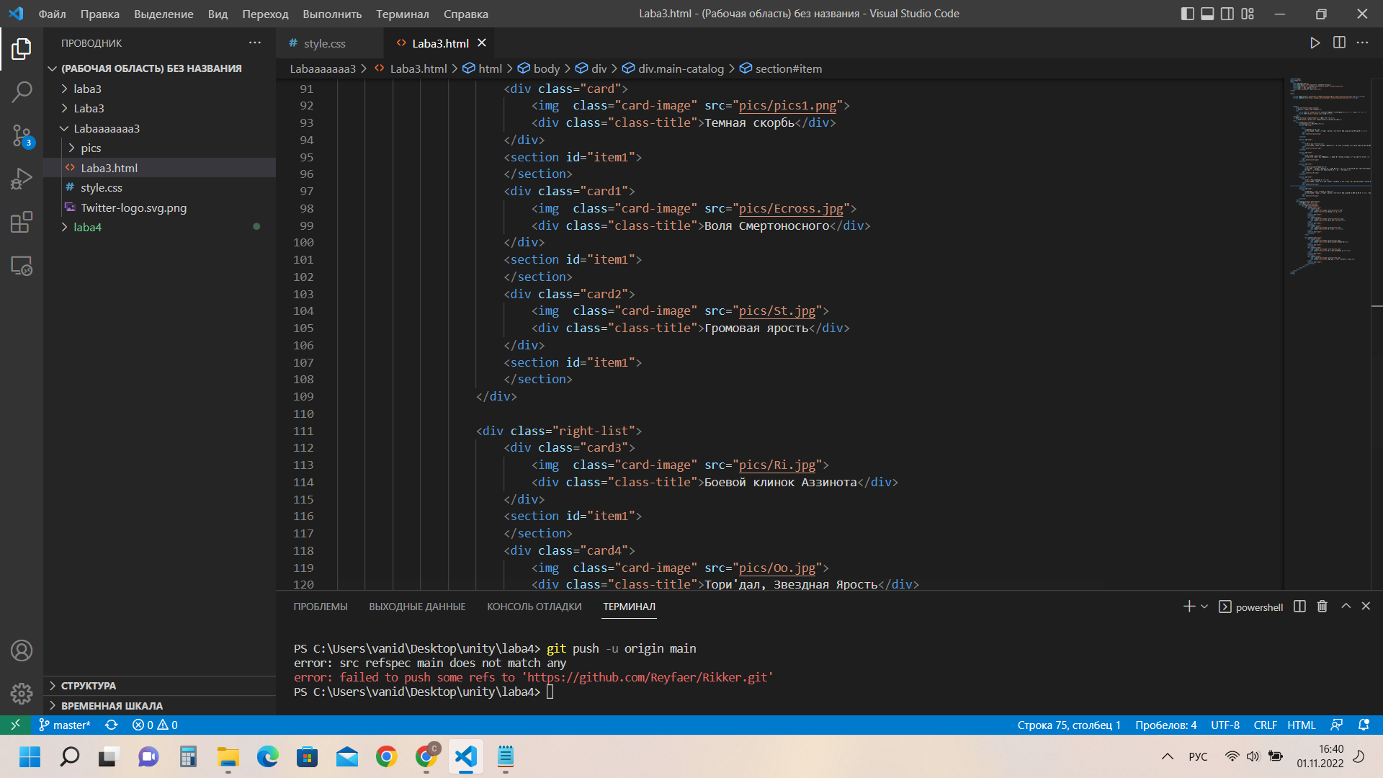

2)CSS-код

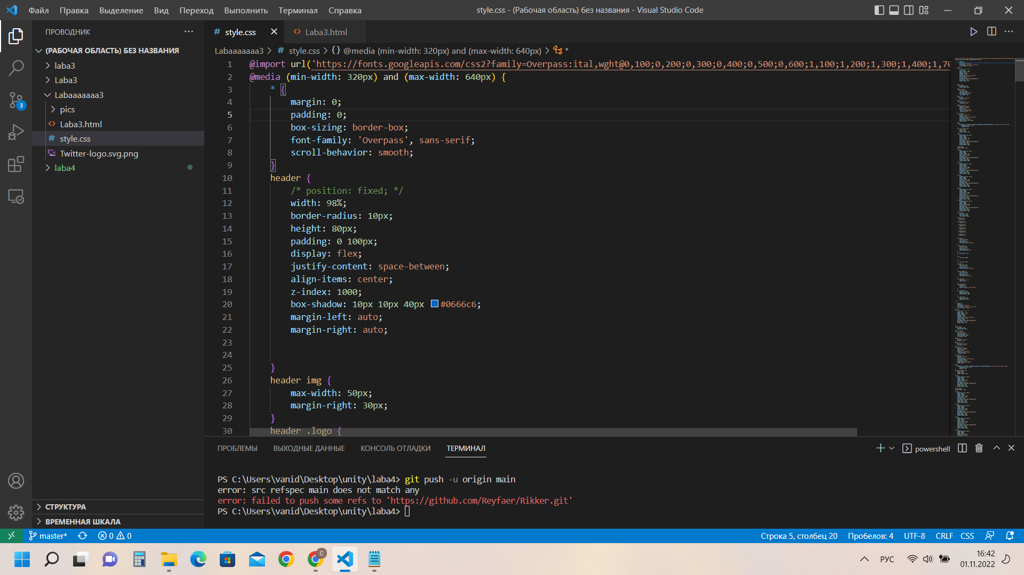

@import url('https://fonts.googleapis.com/css2?family=Overpass:ital,wght@0,100;0,200;0,300;0,400;0,500;0,600;1,100;1,200;1,300;1,400;1,700&display=swap');

@media (min-width: 320px) and (max-width: 640px) {

* {

margin: 0;

padding: 0;

box-sizing: border-box;

font-family: 'Overpass', sans-serif;

scroll-behavior: smooth;

}

header {

/* position: fixed; */

width: 98%;

border-radius: 10px;

height: 80px;

padding: 0 100px;

display: flex;

justify-content: space-between;

align-items: center;

z-index: 1000;

box-shadow: 10px 10px 40px #0666c6;

margin-left: auto;

margin-right: auto;

}

header img {

max-width: 50px;

margin-right: 30px;

}

header .logo {

color: #ace;

font-size: 30px;

text-decoration: none;

letter-spacing: 3px;

font-weight: 700;

}

header ul {

position: relative;

display: flex;

}

header ul li {

position: relative;

list-style: none;

}

header ul li a {

position: relative;

padding: 5px 10px;

color: #ace;

display: inline-block;

text-decoration: none;

cursor: pointer;

}

section#item {

position: relative;

display: flex;

justify-content: space-between;

min-height: 100vh;

align-items: center;

padding: 100px 14px 100px;

color: #111;

}

body{

background: url(https://images5.alphacoders.com/755/755560.jpg) no-repeat center center fixed;

background-size: cover;

padding: 12px;

}

div.main-catalog img {

width: 70px;

height: 70px;

border-radius: 10px;

}

.card{

background-color: #fff;

width: 200px;

height: 150px;

border-radius: 20px;

padding: 20px;

text-align: center;

box-shadow: 10px 10px 40px #be053d;

margin-left: 12px;

margin-right: 12px;

margin-bottom: 10px;

}

.card-image{

border-radius: 11px;

}

.card1{

background-color: #fff;

width: 200px;

height: 150px;

border-radius: 20px;

text-align: center;

padding: 20px;

box-shadow: 10px 10px 40px #be053d;

margin-left: 12px;

margin-right: 12px;

margin-bottom: 10px;

}

.card2{

background-color: #fff;

width: 200px;

height: 150px;

border-radius: 20px;

text-align: center;

padding: 20px;

box-shadow: 10px 10px 40px #be053d;

margin-left: 12px;

margin-right: 12px;

margin-bottom: 10px;

}

.card3{

background-color: #fff;

width: 200px;

height: 150px;

border-radius: 20px;

text-align: center;

padding: 20px;

box-shadow: 10px 10px 40px #be053d;

margin-left: 12px;

margin-right: 12px;

margin-bottom: 10px;

}

.card4{

background-color: #fff;

width: 200px;

height: 150px;

border-radius: 20px;

text-align: center;

padding: 20px;

box-shadow: 10px 10px 40px #be053d;

margin-left: 12px;

margin-right: 12px;

margin-bottom: 10px;

}.card5{

background-color: #fff;

width: 200px;

height: 150px;

border-radius: 20px;

text-align: center;

padding: 20px;

box-shadow: 10px 10px 40px #be053d;

margin-left: 12px;

margin-right: 12px;

margin-bottom: 10px;

}

.card_tirle{

margin-top: 20px;

font-size: 14px;

font-weight: 500px;

}

.card1:hover{

opacity: 0.4;

}.card2:hover{

opacity: 0.4;

}.card3:hover{

opacity: 0.4;

}.card4:hover{

opacity: 0.4;

}.card5:hover{

opacity: 0.4;

}.card:hover{

opacity: 0.4;

}

a.header-a {

font-size: 24px;

color: black;

margin-left: 12px;

text-decoration: underline;

}

a:hover.header-a {

font-size: 24px;

color: black;

margin-left: 12px;

text-decoration: none;

}

h1 {

margin-left: 14px;

}

h2 {

font-size: 100px;

}

p {

font-size: 80px;

}

a.header-a {

font-size: 24px;

color: black;

margin-left: 55px;

text-decoration: underline;

}

a:hover.header-a {

font-size: 24px;

color: black;

margin-left: 55px;

text-decoration: none;

}

div.catalog {

text-align: start;

width: wrap;

}

#space-between{

display: flex;

width: 20%;

justify-content: space-between;

}

div.left-list {

margin-top: 12px;

padding-right: 6px;

margin-bottom: 20px;

}

div.right-list {

margin-top: 12px;

padding-left: 6px;

}

